Ref: Water Hygiene Risk Assessment – Water Heater / Combination Water Heater

YOUR IMMEDIATE ACTION IS REQUIRED

At previous inspections carried out by PFS approved contractor Nemco Utilities Limited, your site was identified as being ‘low risk’ and there was no requirement to conduct regular monitoring of the system, such as monthly temperature checks of the water. However, the guidance in this area (Approved Code of Practice L8 & HSG274) has been revised and the criteria for classifying low risk sites have therefore changed.

The changes include a site is no longer being classified as low risk if there is a water heater with a capacity of 16 litre or more; or if there is a combination water heater. This means sites like yours may no longer be classed as low risk. In order to reduce environmental impact and the cost of a visit by Nemco Utilities, we are undertaking a desk top exercise in the first instance to review this.

To facilitate this, we kindly request that you complete the enclosed questionnaire (which should take no more than 10 minutes) and return it by post in the envelope provided to:
Nemco Utilities
12 Hillside Road
Bury St Edmunds
Suffolk, IP32 7EA

Or alternatively email it to orders@nemco-utilities.co.uk

Failure to return the form within 6 weeks of the date of this letter (12th February 2016) will mean PFS have to instruct a contractor to attend site to obtain the information. The deadline for returns is Thursday 24th March 2016. The cost of the visit will be recharged to the site at an approximate cost of £155.00 plus VAT. Please complete as much detail as possible, as insufficient detail may also require a site visit. Following completion of the form, a further site visit may be required to obtain more information regarding the setup of the water within the property.

If you require assistance in completing the form, please do not hesitate to contact the Nemco Office (01284 724503).

We thank you for your assistance in this matter.

LOW RISK SITE REVIEW FORM

Site Name  (e.g. Bromley Template Corps) | Southsea – Noah’s Ark Nursery
Full Address | 28 Brookfield Road  Fratton  Portsmouth  PO1 5HZ
Contact Name | Sandra Maritz
Telephone Number | 02392 824573

Question |  | Answer
1. | How often are the premises used in a week? | Daily Monday - Friday
2. | Do you hold a copy of the original risk assessment on site? | Yes | No | Don’t Know
3. | If there were remedial works identified, have these been carried out? | Yes | No | Don’t Know
4. | In the last 2 years, has there been  changes to the water system?  change of use of the building?  any water outlets added?  any water outlets removed?  If you have answered yes to any of these questions, please provide details below: | Yes  Yes  Yes  Yes | No  No  No  No | Don’t Know  Don’t Know  Don’t Know  Don’t Know
5. | Are there any water outlets that get used less than weekly? | Yes | No | Don’t Know
6. | If yes, do you flush these each week and record this action? | Yes | No | Don’t Know
7. | Are there any showers or spray taps present on site? | Yes | No | Don’t Know

Please turn over…

8.  a.  b. | Please confirm which hot water system you have on site (you may have various ones present). Where present, please also confirm the temperature each one is set at (ideally direct from the tap, not the dial):  Combi boiler (heats both hot water and heating):  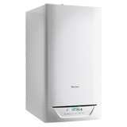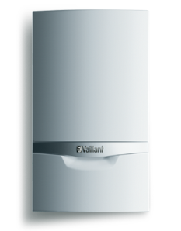  If present, temperature -  Point of use water heaters (sometimes replaces the hot tap on a sink or located below the sink):  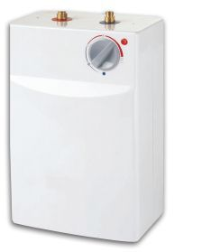  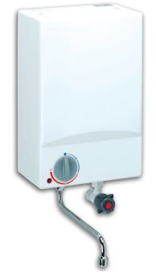  If present, temperature - | Yes  Yes | No  No | Don’t Know  Don’t Know
c.  d. | 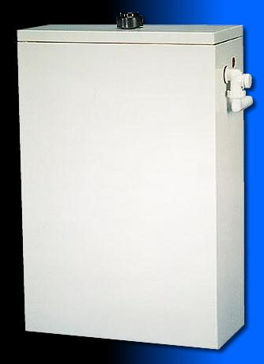  Combination water heater (with a small cold water tank at the top – visible if you lift up the lid and see a ball valve):  If present, temperature -  Water heaters 16 litres or over  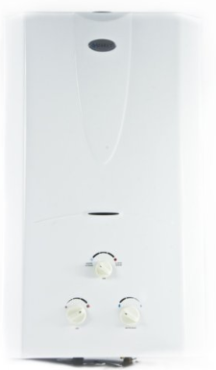 | Yes  Yes | No  No | Don’t Know  Don’t Know
9. | If known, what are the manufacturers, model numbers and year of installation for your water heater(s)?  Type…………………………………………………….  Make  Model  Installation date  Type…………………………………………………….  Make  Model  Installation date
If you have any further comments or information you would like to give about the hot water system within your building, please do so in the space below:

Thank you for completing this questionnaire.

