BOARD ORDER  From: Flude Property Consultants |  |  |  | 
Contact: | Sebastian – 023 9262 9000
Date: | 04 September 2025
PROPERTY ADDRESS
Endeavour Quay, Second Floor Unit 7, Mumby Road, Gosport, Hampshire, PO12 1AH
PLEASE REMOVE BOARD
Action Required: |  | Board Removal
Board to Use: |  | Portsmouth
Type: |  | Choose an item.
Size: |  | Choose an item.
No. of Slips: |  | 2
PLEASE REMOVE BOARD
Front Side  (Orange background with white lettering) |  |  | Open plan Office Suite  Total Size - 694 sq ft
 |  |  | Let
Reverse Side  (Orange background with white lettering) |  |  | SOLD (STC)
FIXING INSTRUCTIONS
Please remove board.

PHOTO O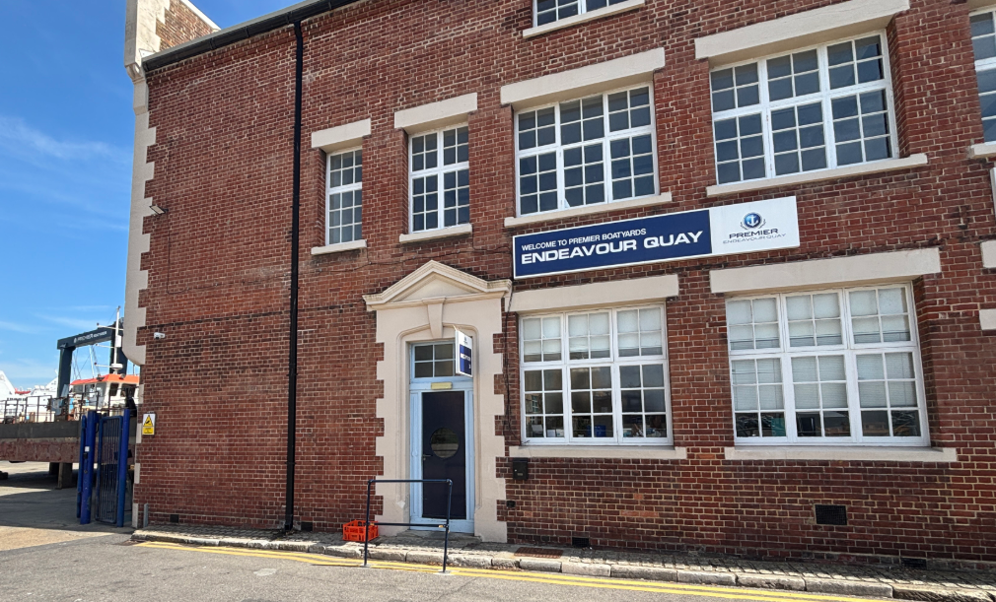F PROPERTY

